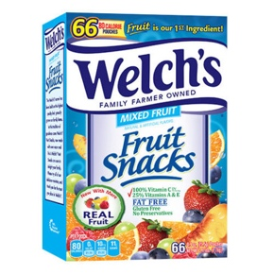
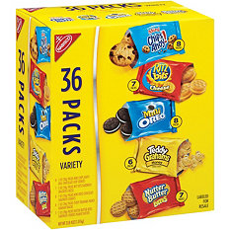
VBS Needs
Please bring items to Jenniffer Case
as soon as you can
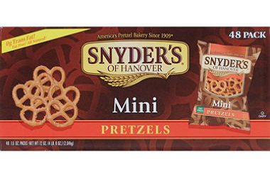
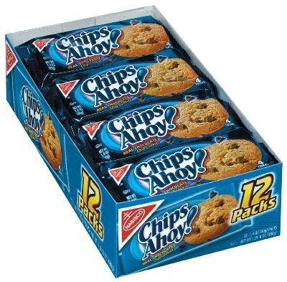

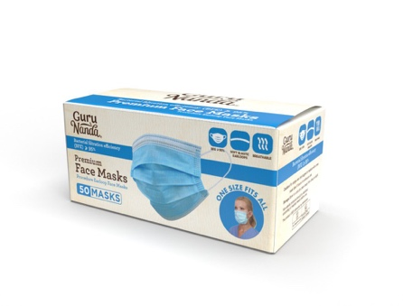
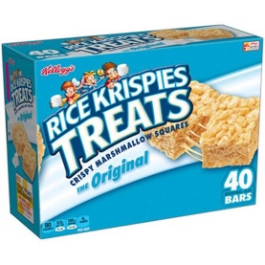
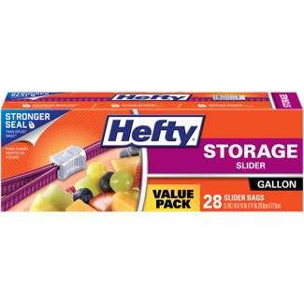

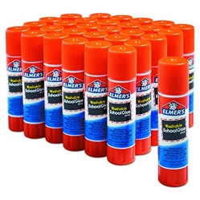
Snacks…..Snacks…..Snacks…..Snacks…..Snacks…
- Individually wrapped snacks
- Glue Sticks
- Laminating Pouches
- Gallon Size Storage Bags
- Sealed boxes of Disposable Face Masks
- Gift cards to Sam’s Club, Wal-Mart, Costco, or
any other store to buy last minute needs

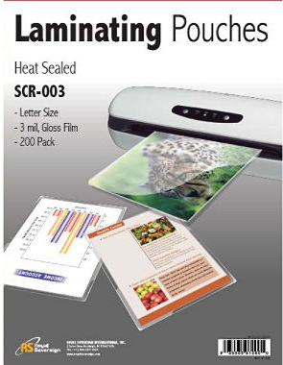
If you would like to help by finding donations for these items or would like to help by donating part of these supplies please see Jenniffer Case in Children’s Ministry.

Updated 7/16/2020

